Environmental Services

[Overview]

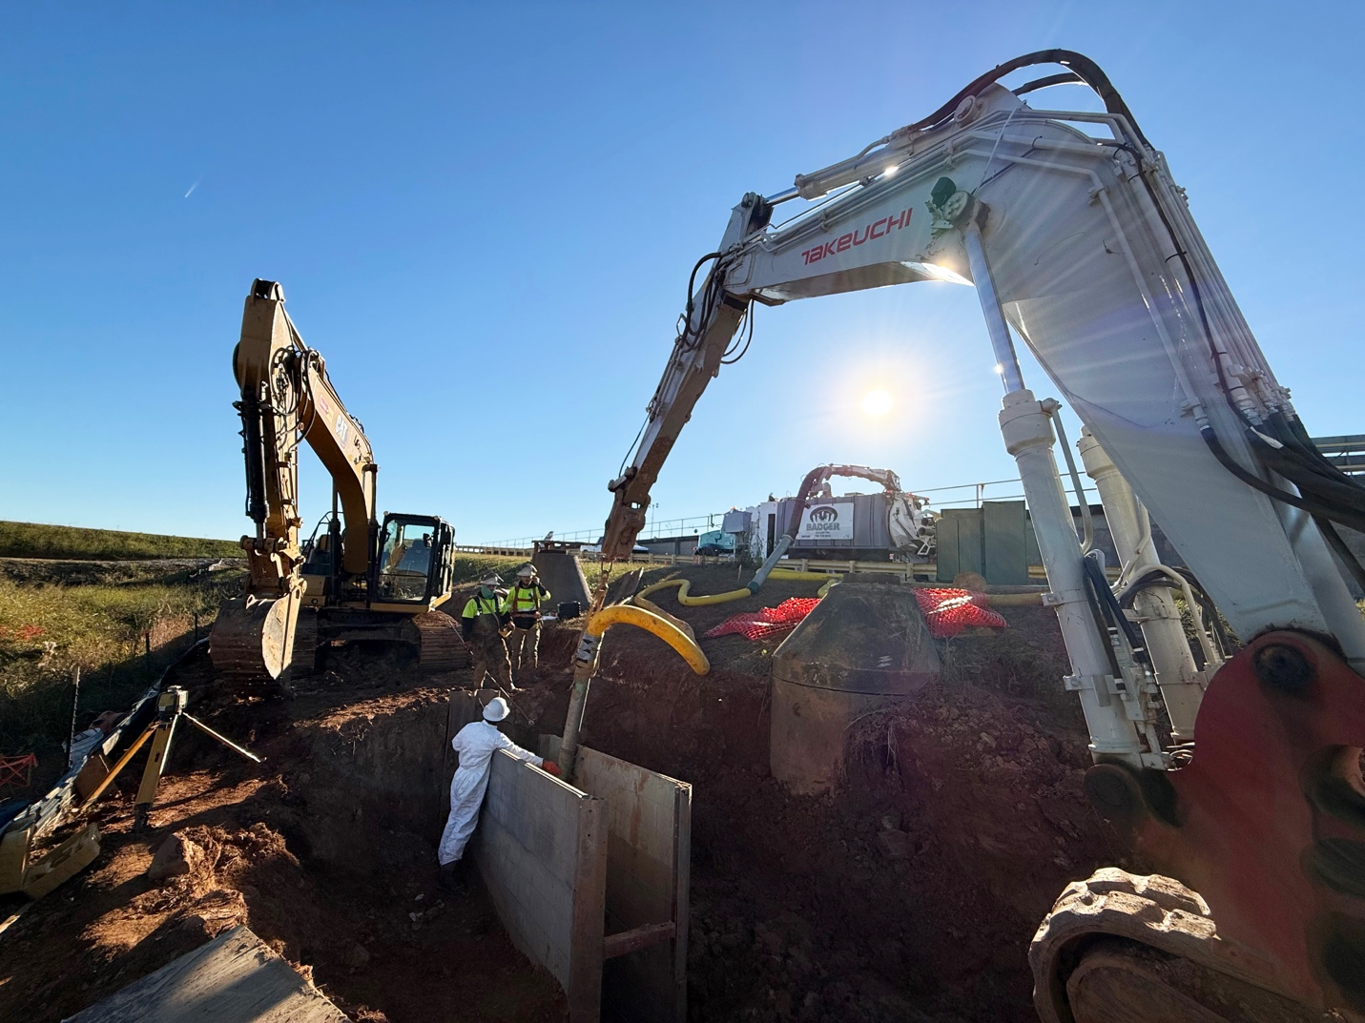

[Icon] INDUSTRIES SERVED
Environmental Services
Partnering with environmental professionals for over 40 years

Consultants in need of environmental contracting services recognize that Summit is the go-to source for subsurface investigations and remediation services.

From Maine to Florida, Summit offers the industry’s most comprehensive, effective and efficient geophysical, drilling and remediation services. Their dedicated, experienced environmental field talent deliver the most effective integrated solutions regardless of site conditions.

Leading environmental contracting companies, such as Summit, deliver crews that combine technical expertise and rigorous health and safety training with the practical experience needed to address virtually any environmental requirement. With a strong emphasis on project management and quality control, clients are ensured to have their needs met efficiently and cost effectively.

Summit utilizes state-of-the-art environmental technologies to support their geophysical, drilling and remediation solutions while providing industry-leading expertise to their multi-regional customers ensuring exceptional results.

Summit’s Lauren DiVello is a dedicated and experienced customer advocate. Reach Lauren at 609-238-2815 to discuss your project needs. Or email LDivello@SummitDrilling.com and she will reply promptly.

[Stat-a-Project Form]

